Q1) Now we are down to a single result set. What is the DM_NAME for the production system which uses the database_user WDDW?
A1) WDDW PROD

Q2) How many records were in the Data Warehouse in March 2015?
A2) 773299244

Q3) How many records were in the Data Warehouse in June 2015?
A3) 809525025

Q4) What is the record count returned by this query?
A4) 9975481676

Q5) Why does this number not accurately reflect the number of records in the data warehouse?
A5) it sums the row_counts from all 12 monthly snapshots in 2015, counting the records multiple times instead of providing the count at a single point in time.

Q6) Which of the data marts had the lowest number of records in March 2015?
A6) EMN PROD, only 75586

Q7) How many records were in the GL_DETAIL_FC table in March 2015?
A7) 42874496
Q8) What was the record count for GL_DETAIL_FC in January 2014?
A8) 31045024
Q9) What was the longest “full_load_time” during the month of March, 2015?
A9) 550

Q10) Which Data Mart (DM_NAME) had the lowest average load time for February, 2013?
A10) FIKFSD 11G PROD, only 5 avg

Q11) What was the shortest_full_load_time for the CR PROD data mart February 2015?
A11) 147

Q12) Write the SQL to produce the following result set. (The column names, values, and record order should match).

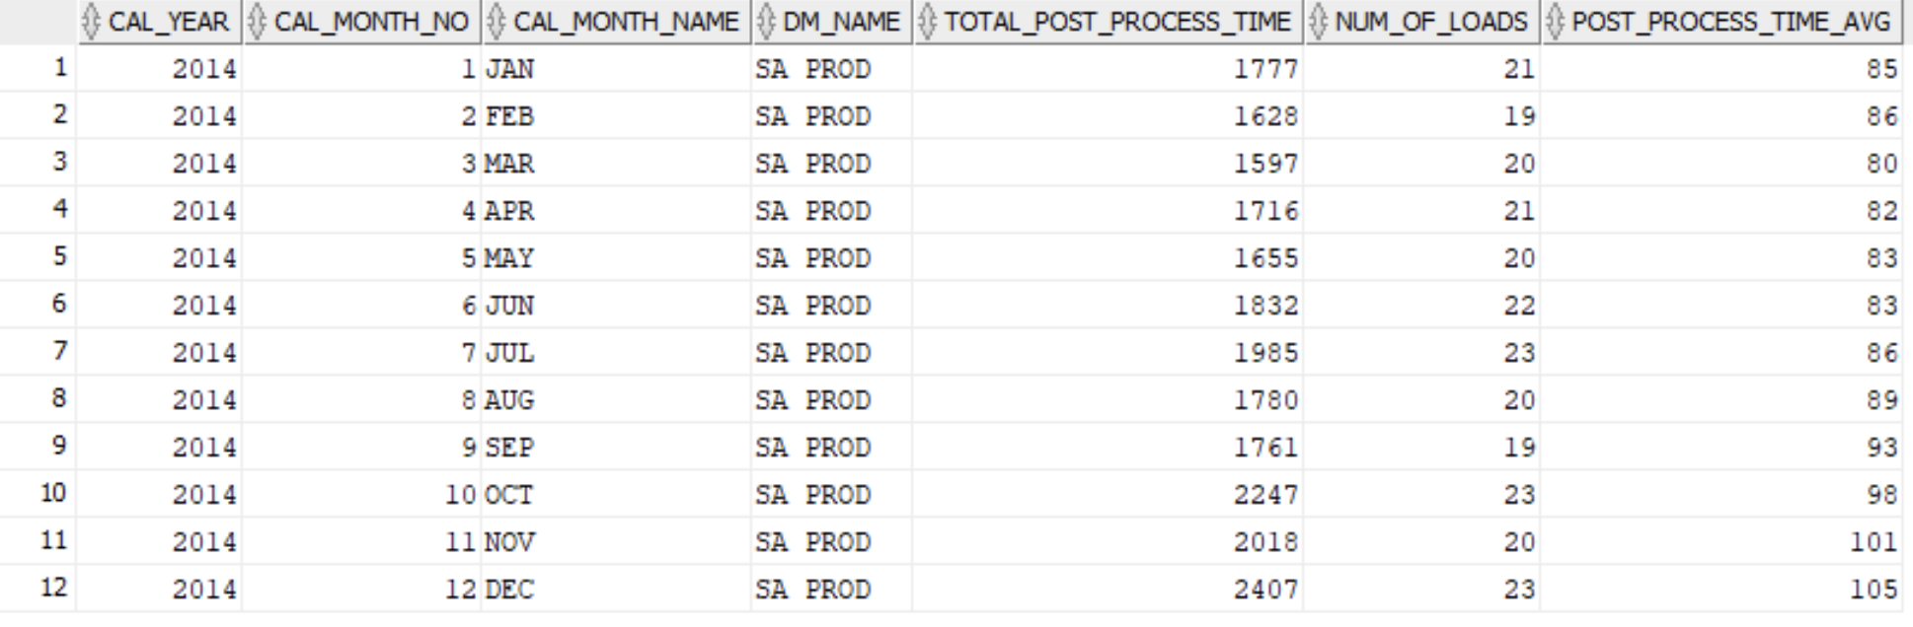

Past SQL here)
SELECT dt.cal_year, dt.cal_month_no, dt.cal_month_name, dm.dm_name, SUM(lt.post_process_time) total_post_process_time, count(1) num_of_loads, ROUND(SUM(lt.post_process_time)/count(1)) post_process_time_avg FROM ODAAMETRICS.load_times_fc lt, ODAAMETRICS.dim_date dt, ODAAMETRICS.datamart_dm dm WHERE lt.dim_date_key = dt.dim_date_key and dm.dm_name_id = lt.dm_name_id and dt.cal_year = 2014 and dm.dm_name = 'SA PROD' group by dt.cal_year, dt.cal_month_no, dt.cal_month_name, dm.dm_name order by dt.cal_month_no;

